Functional Requirements Document (FRD)
Maitribodh Access Management System (MAMS)
Item | Value
Document | Functional Requirements Document
Version | 1.2 (aligned with BRD v1.2 requirement clarifications)
Date | 7 October 2026
Status | Draft for review
Scope | Phase 1 (MVP) for one Ashram; English only; responsive web application
Changes in version 1.2
Area | Change
Categories | Admin creates, updates and deletes categories with no approval; changes apply immediately. Broad categories Volunteer, Active Member and Visitor recorded; Devotee is registered as Visitor (4.1, 4.2)
Permissions | New Permission Level master; categories map to a permission level that persons inherit (3.8, 4.9)
Registration fields | Nationality type replaced by Resident Status; Passport disabled for Residents and mandatory for Non-Resident / International; new Assigned role / permission level and Assigned location(s) fields (6.2, 6.3)
Group visitors | Additional people renamed Accompanying members, added under the primary registrant; labourers need not be registered individually (6.4, 9, 11)
Bulk upload | New Bulk Upload function in Phase 1, controlled by permission (6.5)
Locations and gates | Location master split into gates and areas (open or restricted); location assignment; gate recorded at check-in and check-out; manual location access check at the gate (4.5, 17, 18, 19)
QR | Unique QR for every registered individual from manual registration or bulk upload; manual distribution (15)
OTP and notifications | OTP, SMS, WhatsApp and Email excluded from Phase 1 due to recurring operational cost (5, 16, 23)
Audit | Audit scope extended to every data modification, user, profile, permission, bulk upload and gate movement events (24)
DPDP | DPDP compliance applies; detailed requirements pending (27)
Figures | Figures 8 and 11 redrawn; new figures added for permissions, categories, premises, registration, bulk upload, QR, check-in and check-out, and audit; figures renumbered

Contents
1. Purpose
2. System Overview
3. User Roles
4. Master Data Management
5. User Management Module
6. Person Registration Module
7. Staff Registration
8. Parivar Member Registration
9. Visitor Registration
10. Vendor Registration
11. Contractor Registration
12. Participant Registration
13. Registration Search Module
14. Approval Module
15. QR Management Module
16. Public QR Download Module
17. Gate Verification Module
18. Check-In Module
19. Check-Out Module
20. Occupancy Module
21. Blacklist Module
22. Reports Module
23. Notification Requirements
24. Audit Log Module
25. Error Messages
26. Complete Business Flow
27. Assumptions

1. Purpose
The purpose of this document is to describe how the Maitribodh Access Management System will work from an end-user perspective. It defines screen-level behaviour, field rules and conditions that the development and testing teams build and verify.
This document explains:
- Functional requirements for every module
- Business validations and field rules
- User actions by role
- Screen behaviour and system messages
- Approval flows
- QR generation and the public QR download process
- Gate verification, check-in and check-out
- Occupancy, overstay, blacklist, reporting, notification and audit requirements

2. System Overview
The Maitribodh Access Management System (MAMS) is the single register of everyone who enters the Ashram. It will be used to:
- Register all persons entering the Ashram
- Bulk upload persons (permission-controlled)
- Generate a unique QR code for every Active registration, whether registered manually or through bulk upload
- Let a person download their QR from a public lookup page using the registered mobile number
- Verify persons at the gate by QR scan or mobile search
- Perform check-in and check-out across multiple gates with the gate and location recorded
- Assign locations to persons and manage open and restricted area access, enforced manually by Security
- Approve Staff and Parivar Members
- Block blacklisted persons
- Track occupancy and raise overstay alerts
- Generate reports and keep a complete audit trail

2.1 Person and visit status models
Only Active persons can check in, and each person has at most one open visit. Blacklisting is a separate flag on the person, checked at every scan, so lifting it returns the person to the status they already held.
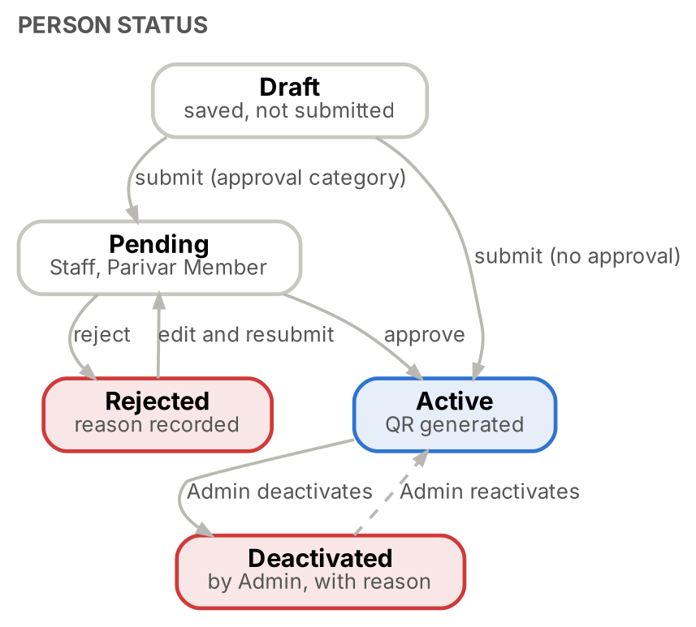
Figure 1. Person status lifecycle
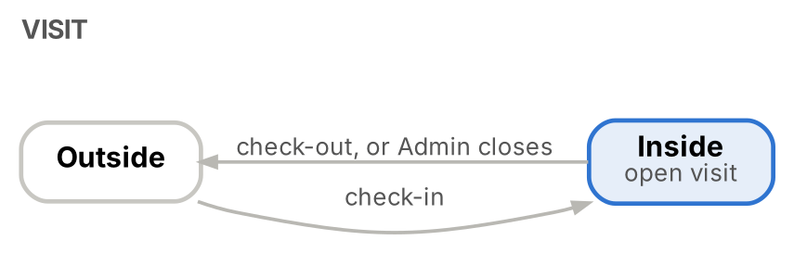
Figure 2. Visit lifecycle
Status | Meaning | Can check in?
Draft | Form saved but not submitted; visible to its creator and Admin; removed after 7 days | No
Pending | Staff or Parivar Member waiting for approval | No
Active | Approved, or registered in a category that needs no approval; QR generated | Yes, if not blacklisted and not already inside
Rejected | Approval refused with a reason; can be edited and resubmitted | No
Deactivated | Disabled by Admin with a reason; Admin can reactivate | No

3. User Roles
Six portal roles are used. Permissions are enforced by the server on every request; the screen only hides what a role cannot use. Persons being registered never log in.

3.1 Super Admin
Type | Description
Permission | Added by the IT team directly in the database; cannot be created from any screen
Permission | Add, deactivate and reactivate Admin users
Permission | Reset an Admin's password
Permission | All Administrator permissions
Restriction | Only one Super Admin account; it cannot be deleted or deactivated from the portal

3.2 Administrator
Type | Description
Permission | Add and manage Approver, Registration Officer, Security Guard and Viewer users
Permission | Manage all master data
Permission | Register persons in every category
Permission | Edit any person record, including Staff profiles (the only role that can edit Staff)
Permission | Approve and reject registrations
Permission | Deactivate and reactivate persons
Permission | Add and lift blacklist entries
Permission | Review the Inside list and close or correct open visits
Permission | View all reports and export Visit History
Permission | View the audit log
Permission | Create, update and delete categories with no approval workflow; changes take effect immediately
Permission | Assign locations to persons and configure location access rights
Permission | Bulk upload persons and grant the bulk upload permission to other users
Restriction | Cannot add or manage Admin users; only Super Admin can

3.3 Approver
Type | Description
Permission | Register persons in every category
Permission | Edit non-Staff person records
Permission | Approve Staff and Parivar Member registrations
Permission | Reject registrations with a reason
Permission | Print QR at the front desk
Permission | Perform check-in and check-out
Permission | View reports, check-in and check-out history, and export Visit History
Restriction | Cannot edit Staff profiles
Restriction | Cannot manage master data or users
Restriction | Cannot blacklist
Restriction | Cannot delete or deactivate records
Restriction | Cannot approve a registration they submitted

3.4 Registration Officer
Type | Description
Permission | Register all person categories
Permission | Edit non-Staff registrations and resubmit rejected records
Permission | Print QR at the front desk
Permission | Perform check-in and check-out
Permission | View reports and export Visit History
Restriction | Cannot approve or reject
Restriction | Cannot edit Staff profiles
Restriction | Cannot manage masters
Restriction | Cannot delete records

3.5 Security Guard
Type | Description
Permission | Scan QR
Permission | Search person by mobile number or Person ID
Permission | Validate the person against the profile photo (accountable for this check)
Permission | Check-in and check-out
Permission | Register a walk-in Visitor
Permission | Select the gate and location at shift start
Permission | Manually validate location access against the person’s assigned locations
Restriction | Cannot edit existing records
Restriction | Cannot approve
Restriction | Cannot manage masters
Restriction | Cannot view reports or the dashboard

3.6 Viewer
Type | Description
Permission | View the dashboard
Permission | View reports
Restriction | View only: no operations and no export

3.7 Permission matrix
Permission | Admin | Approver | Reg. Officer | Security Guard | Viewer
Add / manage Admin users | Super Admin only | No | No | No | No
Add / manage other portal users | Yes | No | No | No | No
View dashboard | Yes | Yes | Yes | No | Yes
Search and view persons | Yes | Yes | Yes | Gate view only | No
Register Staff / Parivar Member | Yes | Yes | Yes | No | No
Register Visitor, Vendor, Contractor, Participant | Yes | Yes | Yes | Visitor only (walk-in) | No
Edit person profile (non-Staff) | Yes | Yes | Yes | No | No
Edit Staff profile | Yes | No | No | No | No
Deactivate / reactivate person | Yes | No | No | No | No
Approve / reject | Yes | Yes | No | No | No
Print QR at front desk | Yes | Yes | Yes | No | No
Check-in / check-out | Yes | Yes | Yes | Yes | No
Close or correct open visits | Yes | No | No | No | No
Blacklist add / lift | Yes | No | No | No | No
View reports | Yes | Yes | Yes | No | Yes
Export Visit History | Yes | Yes | Yes | No | No
View unmasked ID numbers | Yes | No | No | No | No
Master data | Yes | No | No | No | No
Bulk upload | Yes | If granted | If granted | No | No
Assign locations and access rights | Yes | No | No | No | No
Audit log | Yes | No | No | No | No

Landing screen: Security Guard lands on the Gate screen; all other roles land on the Dashboard.

3.8 Category permission levels
System access is controlled through predefined roles and permissions. Each category can be associated with a predefined permission level (Permission Level master, 4.9). A person registered in a category inherits the permission level mapped to that category; the level is shown on the registration and on the gate screen, and is used with the assigned locations when the guard validates location access.
Portal-user permissions such as bulk upload are granted to individual users by Admin. The final list of permission levels is still to be confirmed (BRD OI-18).
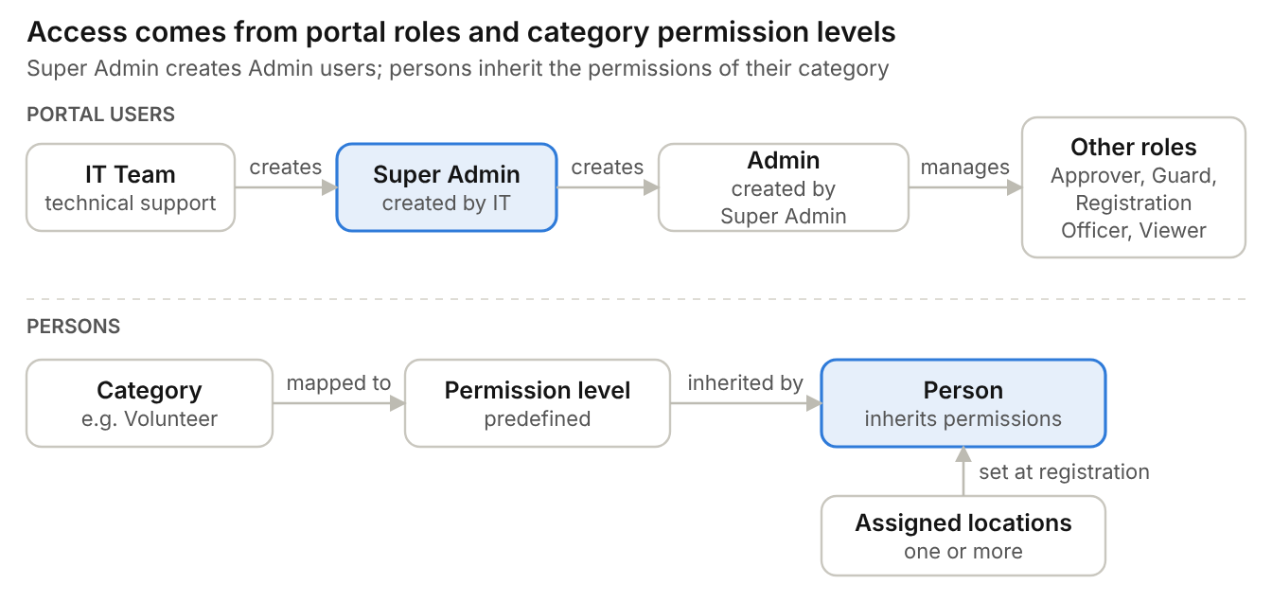
Figure 3. Portal roles and category permission levels

4. Master Data Management
Admin maintains every list below from the Master Data screen without code changes. A value that is already used by records can be deactivated but not deleted; deactivated values are hidden from new entries and kept on existing records.

4.1 Category Master
Field | Mandatory | Validation
Category name | Yes | Unique; ≤ 50 characters
Description | No | ≤ 200 characters
Approval required | Yes | Yes or No; seeded Yes for Staff and Parivar Member, No for others
Permission level | Yes | From Permission Level master; persons in the category inherit it
Overstay cut-off time | No | Time of day after which a person still inside raises an overstay alert (for example 10:00 PM)
Status | Yes | Active or Inactive

Examples / seed values: Staff, Visitor, Vendor, Contractor, Participant, Parivar Member. Broad categories agreed: Volunteer, Active Member and Visitor; mapping to the seed values is to be confirmed (BRD OI-16). Devotee is not a separate category and is registered as Visitor.
# | Validation condition
1 | Category name mandatory
2 | Category name must be unique
3 | At least one category must stay active
4 | Changing the approval flag or cut-off applies to new registrations and future visits only

Admin can: Create, update, activate, deactivate and delete (delete only when unused). No approval workflow applies; changes take effect immediately.
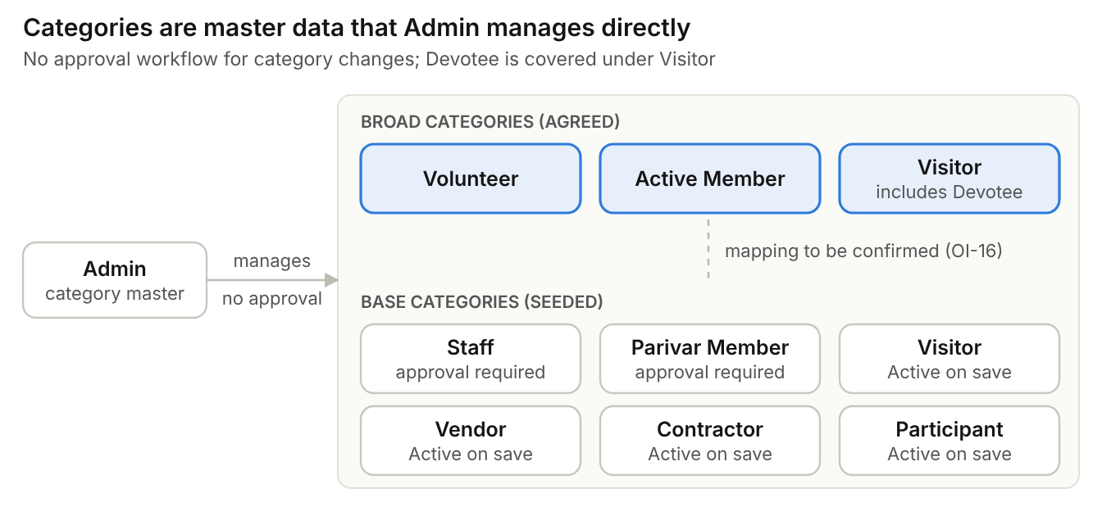
Figure 4. Category model: broad and seed categories

4.2 Subcategory (Member Type) Master
Field | Mandatory | Validation
Category | Yes | Parent category, for example Parivar Member
Subcategory name | Yes | Unique within the category
Status | Yes | Active or Inactive

Examples / seed values: Sevak, Matri
# | Validation condition
1 | Subcategory mandatory
2 | Duplicate value not allowed within the same category

Admin can: Add, edit, activate, deactivate and delete (delete only when unused)

4.3 Department Master
Field | Mandatory | Validation
Department name | Yes | Unique
Status | Yes | Active or Inactive

Examples / seed values: Gurukul, Goushala, Accounts, Security, Housekeeping
# | Validation condition
1 | Department name mandatory
2 | Department name unique

Admin can: Add, edit, activate and deactivate

4.4 Job Role Master
Field | Mandatory | Validation
Department | Yes | From Department master
Job role name | Yes | Unique within the department
Status | Yes | Active or Inactive

Examples / seed values: Teacher, Driver, Guard, Supervisor, Housekeeper, Gardener
# | Validation condition
1 | Job role mandatory
2 | Duplicate role not allowed within the same department

Admin can: Add, edit, activate and deactivate

4.5 Location (Gate and Area) Master
Field | Mandatory | Validation
Location name | Yes | Unique
Type | Yes | Gate or Area
Area access | Conditional | Open or Restricted; mandatory when type is Area
Default for department | No | Department whose persons are tagged to this area automatically, for example Gurukul
Status | Yes | Active or Inactive

Examples / seed values: Gates: Main Gate and other access points. Restricted areas: Kitchen, Offices, Residential Areas, School / Gurukul. Open areas and other areas such as Goushala and Hostel are set by Admin.
# | Validation condition
1 | Location name mandatory
2 | Duplicate location not allowed
3 | Area access (Open or Restricted) mandatory for areas

Admin can: Add, edit, activate and deactivate; mark areas open or restricted
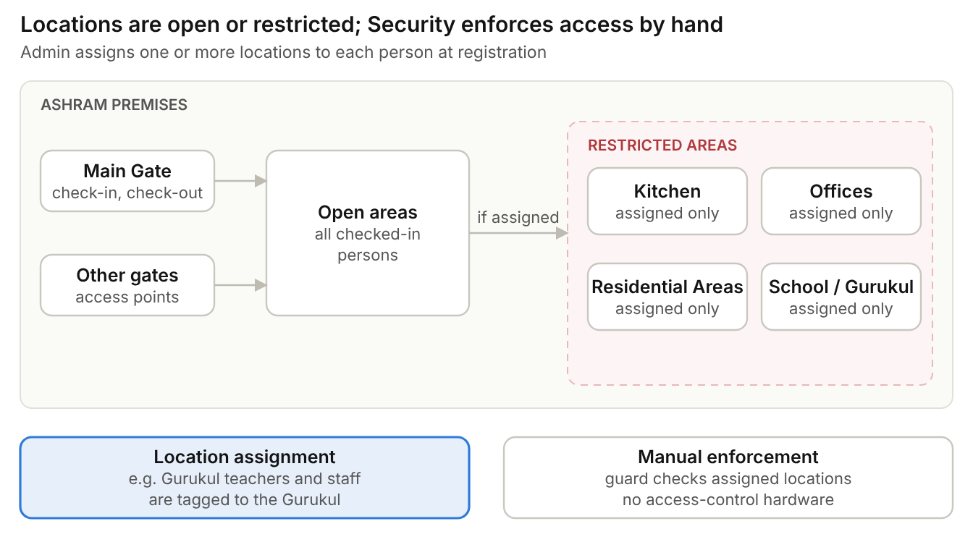
Figure 5. Gates, open areas and restricted areas

4.6 Program and Batch Master
Field | Mandatory | Validation
Program name | Yes | Unique
Batch | Yes | Unique within program
Start date, end date | Yes | End date on or after start date

Examples / seed values: Supplied by the Ashram (meditation programs, workshops, training sessions)
# | Validation condition
1 | End date cannot be before start date

Admin can: Add, edit, activate and deactivate

4.7 ID Proof Type Master
Field | Mandatory | Validation
ID proof name | Yes | Unique
Number pattern | No | Format check for the number
Store masked | Yes | Yes stores only the last 4 digits for non-Admin views; Aadhaar always masked

Examples / seed values: Aadhaar, PAN, Driving Licence, Voter ID, Passport
# | Validation condition
1 | Name unique
2 | Number checked against its pattern when entered

Admin can: Add, edit, activate and deactivate

4.8 Blacklist Reason Master
Field | Mandatory | Validation
Reason | Yes | Unique
Status | Yes | Active or Inactive

Examples / seed values: Supplied by the Ashram
# | Validation condition
1 | Reason unique

Admin can: Add, edit, activate and deactivate

4.9 Permission Level Master
Field | Mandatory | Validation
Permission level | Yes | Unique; predefined list (BRD OI-18)
Description | No | What the level allows, including default location access
Status | Yes | Active or Inactive

Examples / seed values: To be confirmed with Ashram Management
# | Validation condition
1 | Permission level unique

Admin can: View, activate, deactivate and map levels to categories

5. User Management Module
Portal users sign in with username and password. No OTP, email link, SMS or WhatsApp message is used anywhere in login or password handling; OTP is excluded from Phase 1 because of its recurring operational cost.
User type | Created by | How
Super Admin | IT team | Inserted manually in the database; no password
Admin | Super Admin | User Management screen; no password
Approver, Registration Officer, Security Guard, Viewer | Admin or Super Admin | User Management screen; no password

Every user is created without a password. The user creates their own password from the login page at first login.

5.1 Create portal user
Field | Mandatory | Validation
First name | Yes | Letters and spaces; ≤ 100 characters
Last name | Yes | Letters and spaces; ≤ 100 characters
Mobile number | Yes | 10 digits starting 6 to 9; unique among portal users
Email | No | Valid format; unique if entered
Username | Yes | 4 to 50 characters; unique
Role | Yes | Admin (Super Admin only), Approver, Registration Officer, Security Guard or Viewer
Security Head | No | Flag; user receives blacklist and overstay alerts
Status | Yes | Active or Inactive; default Active
Password | System | Empty when created; set by the user at first login

5.2 User creation flow
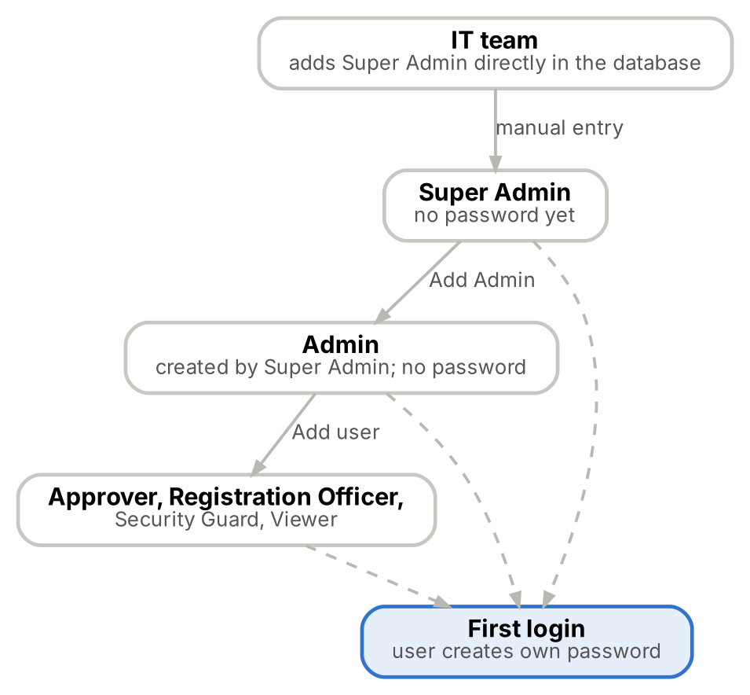
Figure 6. Portal user creation

5.3 Login and password flow
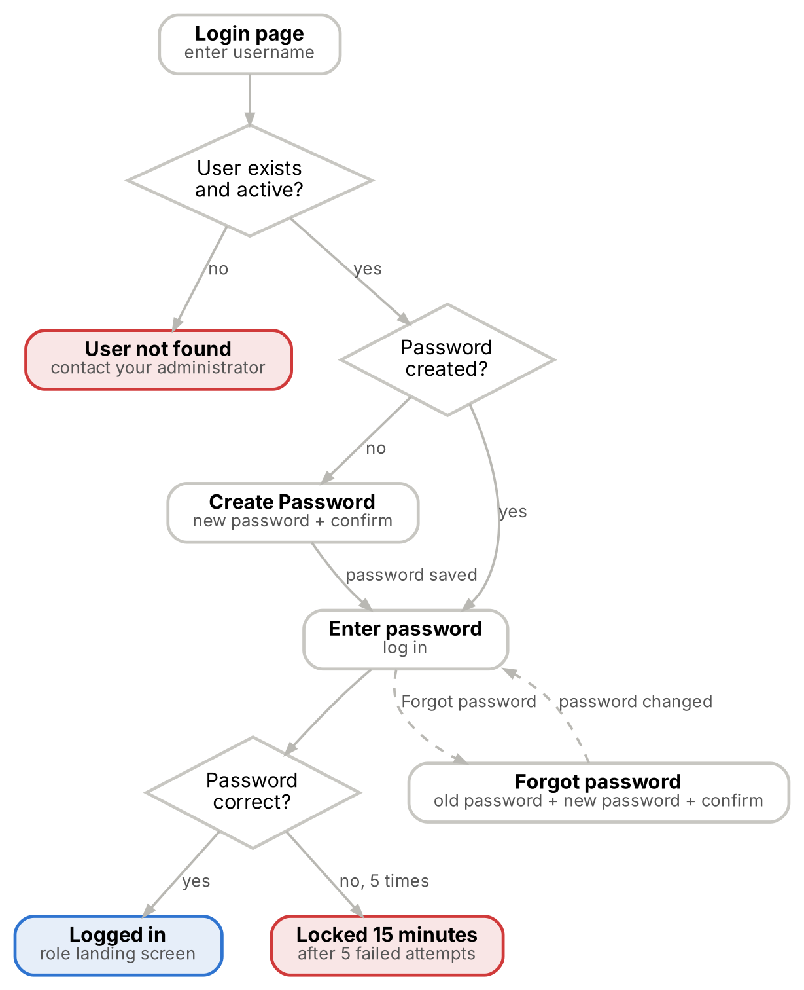
Figure 7. Login, create password and forgot password
Condition at login page | System behaviour | Message
Username not found or user Inactive | Login stopped | MSG-SEC-05
User exists and no password created yet | Shows Create Password: new password and confirm password | —
User exists and password already created | Shows Password field and a Forgot Password option | —
Wrong password | Login refused; failed attempt counted | MSG-SEC-01
5 wrong passwords in 15 minutes | Account locked for 15 minutes | MSG-SEC-02
Correct password | Logged in to the role's landing screen | —

5.4 Create Password (first login)
Field | Mandatory | Validation
Username | Yes | Must exist, be Active and have no password yet
New password | Yes | Minimum 10 characters with letters and digits
Confirm password | Yes | Must match new password (MSG-SEC-07)

On save the password is stored and the user logs in with it (MSG-SEC-03). Create Password is never shown to a user who already has a password.

5.5 Forgot Password (change from login page)
Field | Mandatory | Validation
Username | Yes | Must exist, be Active and already have a password
Old password | Yes | Must match the current password (MSG-SEC-06)
New password | Yes | Minimum 10 characters with letters and digits; must differ from old password (MSG-SEC-08)
Confirm password | Yes | Must match new password (MSG-SEC-07)

On save the new password replaces the old one (MSG-SEC-09). No OTP, email link, SMS or WhatsApp is used.

5.6 Password reset by administrator
Situation | Action | Result
User does not remember the old password | Admin resets the user's password (Super Admin resets an Admin's) | Password cleared; user sees Create Password at next login
Super Admin cannot log in | IT team clears the password in the database | Super Admin sees Create Password at next login

5.7 Login, password and session rules
ID | Requirement
FR-SEC-01 | The Super Admin is added by the IT team directly in the database. Super Admin adds Admins; Admin or Super Admin adds all other users. Every user is created without a password.
FR-SEC-02 | Login page first checks the username. If the user exists, is Active and has no password, the Create Password option is shown; if a password exists, the Password field and Forgot Password option are shown.
FR-SEC-03 | Forgot Password asks for old password, new password and confirm password. There is no OTP, email link, SMS or WhatsApp step.
FR-SEC-04 | Passwords: minimum 10 characters with letters and digits; stored only as a bcrypt hash. After 5 failed attempts in 15 minutes the account locks for 15 minutes (MSG-SEC-02).
FR-SEC-05 | Security Guard session lasts a full 12-hour shift with no idle logout, so the gate is never interrupted. Other roles are signed out after 30 minutes of inactivity (configurable by Admin) with a 1-minute warning (MSG-SEC-04).
FR-SEC-06 | Logout ends the session immediately.
FR-SEC-07 | Admin can deactivate a user, reset (clear) their password and change their role; Super Admin does the same for Admins. Changes take effect on the user's next request.
FR-SEC-08 | Every login, logout, failed login, lockout, password creation, password change and password reset is audited.

6. Person Registration Module
Only authorised portal users register persons; there is no public self-registration. Registration is a three-step form: select category, enter common details with photo, then enter category details.

6.1 Registration flow
Step | User action | System response
1 | Select category | Shows only categories the role can register; others disabled (MSG-REG-07)
2 | Enter mobile number | Lists existing registrations on that number for information (MSG-REG-01); user can continue
3 | Enter common fields (including Resident Status), photo, category fields, assigned role / permission level, assigned location(s) and accompanying members | Validates each field on entry
4 | Save (Staff or Parivar Member) | Status Pending; Approvers notified (MSG-REG-04)
5 | Save (all other categories) | Status Active; QR generated at once (MSG-REG-04)
6 | Save as Draft | Stored without mandatory checks; visible to creator and Admin; removed after 7 days

6.2 Common registration fields
Field | Mandatory | Validation
Person ID | System | MB-nnnnnn, sequential, read-only; one per registration
Category | Yes | From Category master
Assigned role / permission level | Yes | Defaulted from the category’s permission level (Permission Level master)
Assigned location(s) | No | One or more from Location master; persons in a department linked to an area are tagged to it automatically (for example Gurukul teachers and staff)
First name | Yes | Letters, spaces and hyphen only; ≤ 100 characters
Last name | Yes | Letters, spaces and hyphen only; ≤ 100 characters
Mobile number | Yes | 10 digits starting 6 to 9; duplicates allowed
Alternate mobile | No | 10 digits
Gender | Yes | Male, Female or Other
Date of birth | No | Past date; age shown
Resident status | Yes | Resident or Non-Resident / International; default Resident
Passport number | Conditional | Disabled when Resident; mandatory when Non-Resident / International; 6 to 9 letters and digits
Address | Category rule | ≤ 500 characters; mandatory for Staff and Parivar Member
Email ID | No | Valid format if entered
Photograph | Yes | Camera capture or JPG / PNG upload, ≤ 5 MB; resized to 600 px before upload
ID proof type and number | No | From ID Proof master; number pattern checked; masked for non-Admin users
Accompanying members | No | Added under the primary registrant: names, or a count, of people without their own mobile number (labour team, family, children, elderly); no Person ID or QR
Remarks | No | ≤ 500 characters
Registered by, registration date, status | System | Set automatically

6.3 Validation rules
Field | Condition | Result if not met | Message
First / last name | Letters, spaces and hyphens only; ≤ 100 characters | Field error; cannot save | MSG-REG-03
Mobile number | Mandatory; 10 digits starting 6 to 9 | Field error; cannot save | Field error
Mobile number | Already used on other registrations | Information only; save allowed | MSG-REG-01
Photo | Mandatory; JPG or PNG; ≤ 5 MB | Field error; cannot save | MSG-REG-02
Email | Optional; valid format if entered | Field error; cannot save | Field error
Passport number | Mandatory when Resident Status is Non-Resident / International | Field error; cannot save | MSG-REG-08
Passport number | Resident Status is Resident | Field disabled | —
Address | Mandatory for Staff and Parivar Member | Field error; cannot save | Field error

6.4 Registration rules
ID | Requirement
FR-REG-01 | Staff and Parivar Member registrations become Pending; Visitor, Vendor, Contractor and Participant registrations become Active immediately and receive a QR.
FR-REG-02 | Duplicate prevention is not enforced. A person may be registered more than once under different categories; each registration has its own Person ID, status and QR.
FR-REG-03 | Only people with a mobile number are registered as persons. Contractors with labour teams, families, accompanying children and elderly people without a mobile phone are handled by registering a primary individual and adding the accompanying members under that registrant; accompanying members do not get a Person ID or QR. Individual registration of every labourer is not mandatory.
FR-REG-04 | Only Admin can edit a Staff profile, including department and job role; no re-approval is needed. Registration Officers, Approvers and Admin can edit other categories without re-approval.
FR-REG-05 | Changing the mobile number regenerates the QR; other edits never change the QR.
FR-REG-06 | Admin can deactivate a person with a reason; a deactivated person cannot check in and is excluded from the public QR lookup. Admin can reactivate.
FR-REG-07 | Persons are never deleted; history is always kept.
FR-REG-08 | A Security Guard can register only a walk-in Visitor, using the short walk-in form at the gate.
FR-REG-09 | Admin can assign one or more locations to a person during registration. Location assignment changes are audited.
FR-REG-10 | The person inherits the permission level mapped to the selected category; it is stored on the registration and shown at the gate.
FR-REG-11 | Changes to mobile number, email, passport, category and location are audited with old and new values.
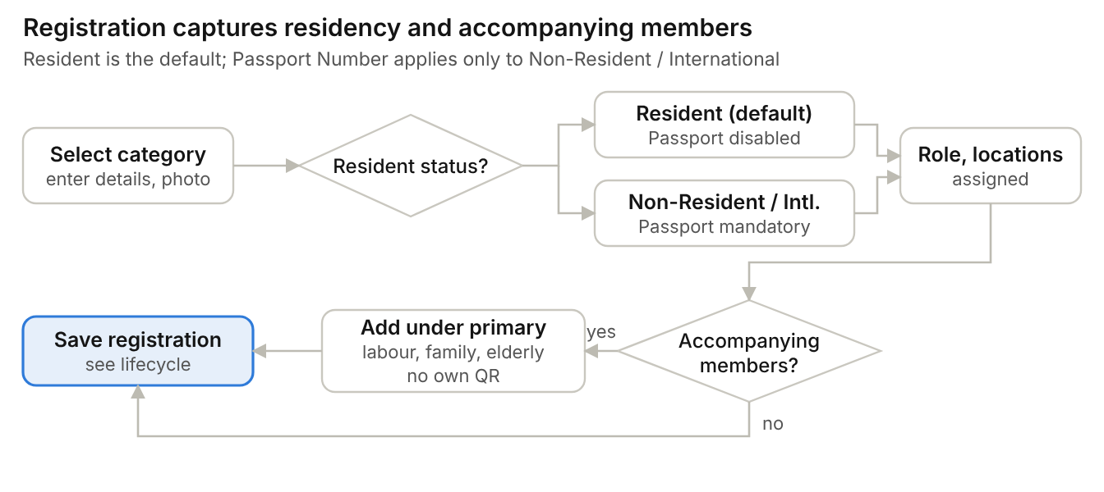
Figure 8. Registration data: residency and accompanying members

6.5 Bulk upload
Bulk upload registers many persons from one file. It is part of Phase 1 and is available only to users granted the bulk upload permission.
Step | User action | System response
1 | Open Bulk Upload | Shown only to users with the bulk upload permission
2 | Download the template | Template file (columns to be finalised, BRD OI-17)
3 | Upload the completed file | Upload initiated and audited
4 | Wait for validation | Each row checked with the rules in 6.2 and 6.3; valid rows saved, invalid rows listed with the reason
5 | Review the result | Summary of created and failed rows; unique QR generated for each created Active record; upload completed and upload errors audited

ID | Requirement
FR-BLK-01 | Bulk upload is available only to users granted the bulk upload permission; the permission is granted by Admin.
FR-BLK-02 | Each row is validated with the same field rules as manual registration. Failing rows are not saved and are reported with the row number and reason.
FR-BLK-03 | A unique QR is generated for each record created by a successful upload.
FR-BLK-04 | Upload initiated, upload completed and upload errors are written to the audit log.
FR-BLK-05 | Still to be finalised (BRD OI-17): template columns, how photographs are supplied, and whether Staff and Parivar Member rows go to the approval queue.
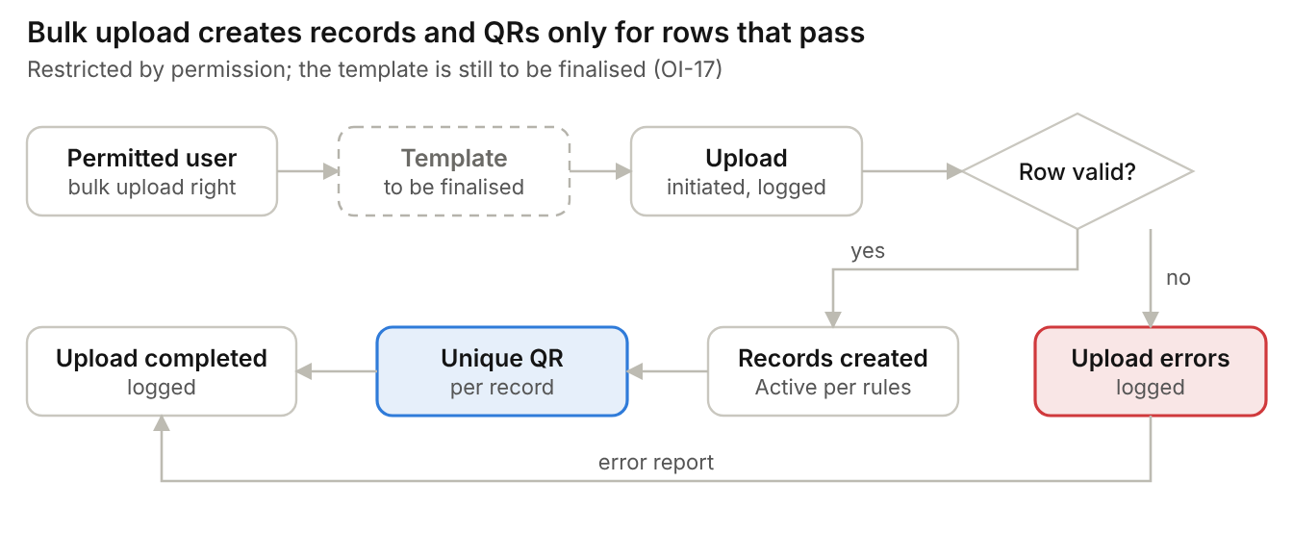
Figure 9. Bulk upload flow

7. Staff Registration
Field | Mandatory | Validation / notes
Department | Yes | From Department master
Job role | Yes | Shows only roles belonging to the selected department
Joining date | Yes | Not in the future
Residential address | Yes | ≤ 500 characters
Emergency contact name and mobile | Yes | Mobile 10 digits
Employee ID | No | Unique if entered
Employment type | No | Permanent, contract or seasonal
Shift | No | Free text
Documents | No | ID proof, appointment letter; PDF, JPG or PNG, ≤ 5 MB each

7.1 Staff registration flow
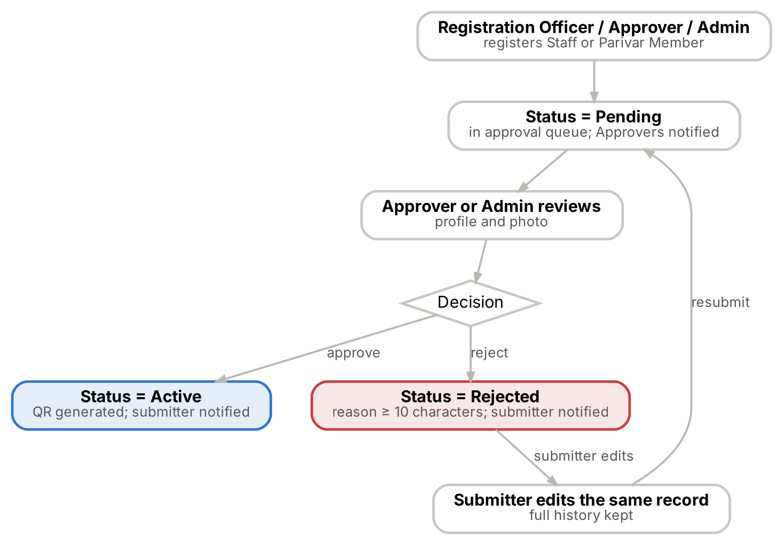
Figure 10. Staff and Parivar Member approval flow
If approved: status becomes Active and the QR is generated. If rejected: status becomes Rejected, the reason is mandatory, and the submitter edits and resubmits the same record.
Status: Pending until approved. Approval required: Yes.

8. Parivar Member Registration
Field | Mandatory | Validation / notes
Subcategory (Member Type) | Yes | From Subcategory master, for example Sevak, Matri
Residential address | Yes | ≤ 500 characters
Emergency contact name and mobile | Yes | Mobile 10 digits
Member since | No | Past date
Seva area | No | Free text
Referred by | No | Free text
Documents | No | ID proof, membership form

Flow: same as Staff (Figure 10): Registration Officer registers → Pending → Approver reviews → Approve or Reject. Approval required: Yes.

9. Visitor Registration
Field | Mandatory | Validation / notes
Purpose of visit | Yes | Free text or list
Visit date | Yes | Today or a future date
City | No | Free text
Person or department to meet | No | Free text
Expected duration | No | Hours
Vehicle number | No | Free text
Accompanying members | No | Family, children, elderly without a mobile phone; names or count

Registered by: Registration Officer, Approver, Admin, or Security Guard (walk-in). Status: Active immediately. Approval required: No. Devotees are registered as Visitors.

10. Vendor Registration
Field | Mandatory | Validation / notes
Firm name | Yes | ≤ 150 characters
Goods or services supplied | Yes | Free text
Receiving department | Yes | From Department master
GSTIN | No | 15-character GST format
Delivery frequency | No | Daily, weekly, occasional
Vehicle number | No | Free text
Business address | No | ≤ 500 characters

Status: Active immediately. Approval required: No.

11. Contractor Registration
Field | Mandatory | Validation / notes
Agency name | Yes | ≤ 150 characters
Nature of work | Yes | Electrical, construction, maintenance and so on
Supervising department | Yes | From Department master
Contract start and end date | Yes | End on or after start
Work order number | No | Free text
Work location | No | From Location master
Accompanying members (labour team) | No | Added under the contractor as primary registrant; individual registration of each labourer is not mandatory

Status: Active immediately. Approval required: No. The contractor is the primary registrant; labour team members are added as accompanying members on the contractor’s registration and at each check-in.

12. Participant Registration
Field | Mandatory | Validation / notes
Program and batch | Yes | From Program and Batch master
Program start and end date | Yes | Filled from the batch
Emergency contact name and mobile | Yes | Mobile 10 digits
City | No | Free text
Accommodation | No | Free text
Dietary or medical notes | No | Visible only to Admin and Registration Officers

Status: Active immediately. Approval required: No. Non-Resident / International participants must enter a Passport Number.

13. Registration Search Module
Search field | Rule | Result
Person ID | Exact match | One registration
Mobile number | 10 digits | All registrations on that number
Name | At least 3 characters; partial match | All matching registrations

Condition | System behaviour | Message
No search field entered | Search not run | MSG-REG-05
No record matches | Empty result shown | MSG-REG-06

13.1 Person list
Element | Behaviour
Columns | Photo, Person ID, name, category, subcategory or department, mobile (masked for non-Admin), status, blacklist flag, registered date
Filters | Category, status, department, assigned location, registered date range
Paging | 25 rows per page; sort by any column
Row actions | View, Edit (by role), Print QR, Deactivate (Admin), Blacklist (Admin)

14. Approval Module
Approvers and Admins work one queue with Pending, Approved and Rejected tabs. Approval is single-level.

14.1 Pending list screen
Column | Description
Registration number (Person ID) | MB-nnnnnn
Photo and person name | Thumbnail and full name
Category | Staff or Parivar Member
Department or subcategory | Department for Staff; subcategory for Parivar Member
Mobile | Masked for non-Admin
Submitted by | Portal user
Submitted date | Date and time
Age of request | Days waiting; default sort oldest first

Filters: category, submitted date range, submitted by. Opening a row shows the full profile, photo and documents before a decision.

14.2 Approve, reject and resubmit
ID | Requirement
FR-APR-01 | Allowed roles: Admin and Approver.
FR-APR-02 | Approve: Pending → Active; QR generated; submitter notified.
FR-APR-03 | Reject: reason mandatory, at least 10 characters (MSG-APR-01); Pending → Rejected; rejector name and date recorded; submitter notified.
FR-APR-04 | Resubmit: the submitter or Admin views the reason, edits the same rejected record and resubmits; Rejected → Pending. No new registration is created and the full approval and rejection history is kept.
FR-APR-05 | Bulk: select up to 50 rows; approve all, or reject all with one shared reason. Each record is audited individually; rows whose status changed since loading are skipped and reported.
FR-APR-06 | A user cannot approve a registration they submitted (MSG-APR-02); Admin is exempt only when they are the sole Admin.

Figure 11. Approval, rejection and resubmission

15. QR Management Module

15.1 QR generation
Category | QR generated
Staff | After approval
Parivar Member | After approval
Visitor | Immediately after registration
Vendor | Immediately after registration
Contractor | Immediately after registration
Participant | Immediately after registration
Any category by bulk upload | After a successful upload (approval categories: to be confirmed, BRD OI-17)

15.2 QR content and rules
ID | Requirement
FR-QR-01 | Every registered individual gets a unique QR, whether registered manually or through bulk upload. The QR carries a signed token built on the Person ID, so it stays unique even when several registrations share one mobile number: AMS1.<Person ID>.<QR version>.<signature>. Example: AMS1.MB000001.1.9f3c…
FR-QR-02 | One QR per registration; accompanying members do not get a QR. The QR never expires.
FR-QR-03 | The QR is regenerated only when the data it is based on changes (the registered mobile number). The version increases by 1 and the previous QR becomes invalid immediately (MSG-GATE-01).
FR-QR-04 | The QR image is a PNG (512 px) with name, Person ID and category printed below it.
FR-QR-05 | Distribution is manual: the person downloads the QR from the public lookup page, or Admin, Approver and Registration Officer print it at the front desk on an A6 card and hand it over.
FR-QR-06 | Automatic sharing of the QR by SMS, Email or WhatsApp is not included in Phase 1 because of recurring operational cost.
FR-QR-07 | Every QR generation and regeneration is audited.
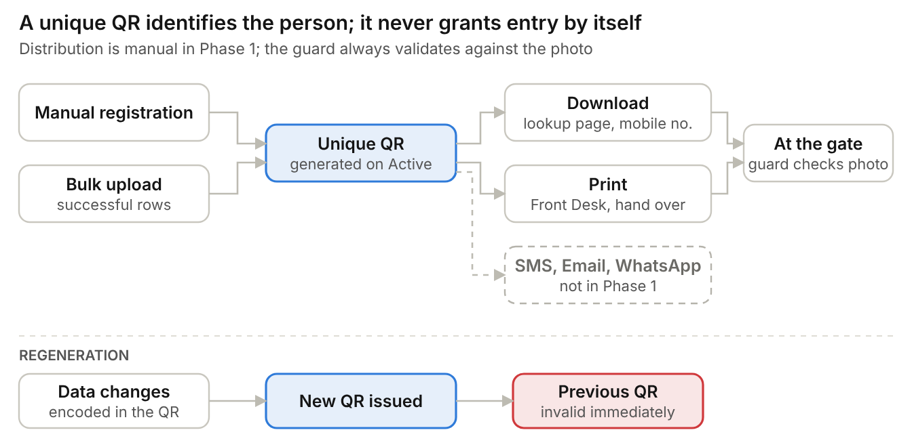
Figure 12. QR generation, distribution and regeneration

16. Public QR Download Module
No login required. No OTP (excluded from Phase 1 due to recurring operational cost), CAPTCHA, rate limit or other security control applies to this page. Security personnel manually validate the person at the gate against the profile photo.

16.1 Search field
Field | Mandatory | Validation
Mobile number | Yes | 10 digits starting 6 to 9

16.2 Flow
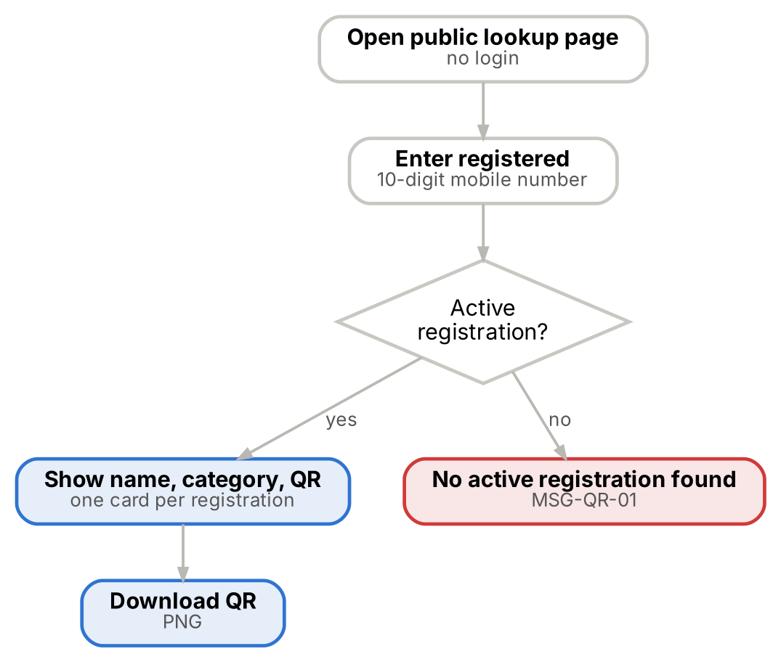
Figure 13. Public QR download
Step | Person action | System response
1 | Opens the public lookup page | Shows mobile number field; no login, OTP or CAPTCHA
2 | Enters registered mobile number and taps Search | Finds Active, non-blacklisted registrations on that number
3 | Views results | One card per registration with name, category and QR
4 | Taps Download | QR downloaded as PNG; shown at the gate

16.3 Validation
Condition | System behaviour | Message
Mobile number not 10 digits | Search not run | Field error
No registration on the number | No QR shown | MSG-QR-01
Registration Pending, Rejected, Deactivated or Blacklisted | No QR shown; status not disclosed | MSG-QR-01
One or more Active registrations | QR card shown for each | —
Every lookup | Written to audit log with masked mobile and result | —

17. Gate Verification Module
The gate screen gives one decision per person: a green Check In / Check Out button, or a red block with the reason. It is designed for a phone or tablet held in one hand. MAMS manages multiple gates and access points; no access-control hardware is used, so Security personnel validate identity and location access manually.

17.1 Gate screen
ID | Requirement
FR-GATE-01 | At shift start the guard selects the gate and the location; the device remembers both until changed.
FR-GATE-02 | Scan mode opens the rear camera in the browser and reads continuously; a beep and vibration confirm a read. Torch toggle available.
FR-GATE-03 | Search mode accepts mobile number or Person ID; more than one match shows a picker with photos and categories.
FR-GATE-04 | The guard compares the person with the profile photo before tapping Check In; the guard is accountable for this validation.
FR-GATE-05 | The gate screen shows the person’s assigned locations and permission level. When the selected location is a restricted area the person is not assigned to, the screen shows a warning (MSG-GATE-08) and the guard refuses entry. Open areas need no assignment.

17.2 Security screen information
Field | Shown as
Photo | Large photo for visual comparison
Name | Full name
Person ID | MB-nnnnnn
Category | With subcategory or department
Assigned locations | List of assigned locations; restricted areas flagged
Mobile number | Masked, last 4 digits
Status | Active, Pending, Rejected or Deactivated
Blacklist status | Red banner when blacklisted
Inside / Outside | With time, gate and location of the open visit
Accompanying members | Names or count recorded on the registration

17.3 Eligibility check (server-side, in this order)
# | Check | If it fails | Message
1 | QR signature and version valid | Block | MSG-GATE-01
2 | Person exists | Offer walk-in Visitor registration | MSG-GATE-02
3 | Not blacklisted today | Block; red alert; notify Admins and Security Head | MSG-GATE-03
4 | Status is Active | Block | MSG-GATE-04
5 | No open visit | Block check-in; offer Check Out | MSG-GATE-06
6 | Assigned to the selected location (restricted areas only) | Warning; guard refuses entry if not permitted | MSG-GATE-08

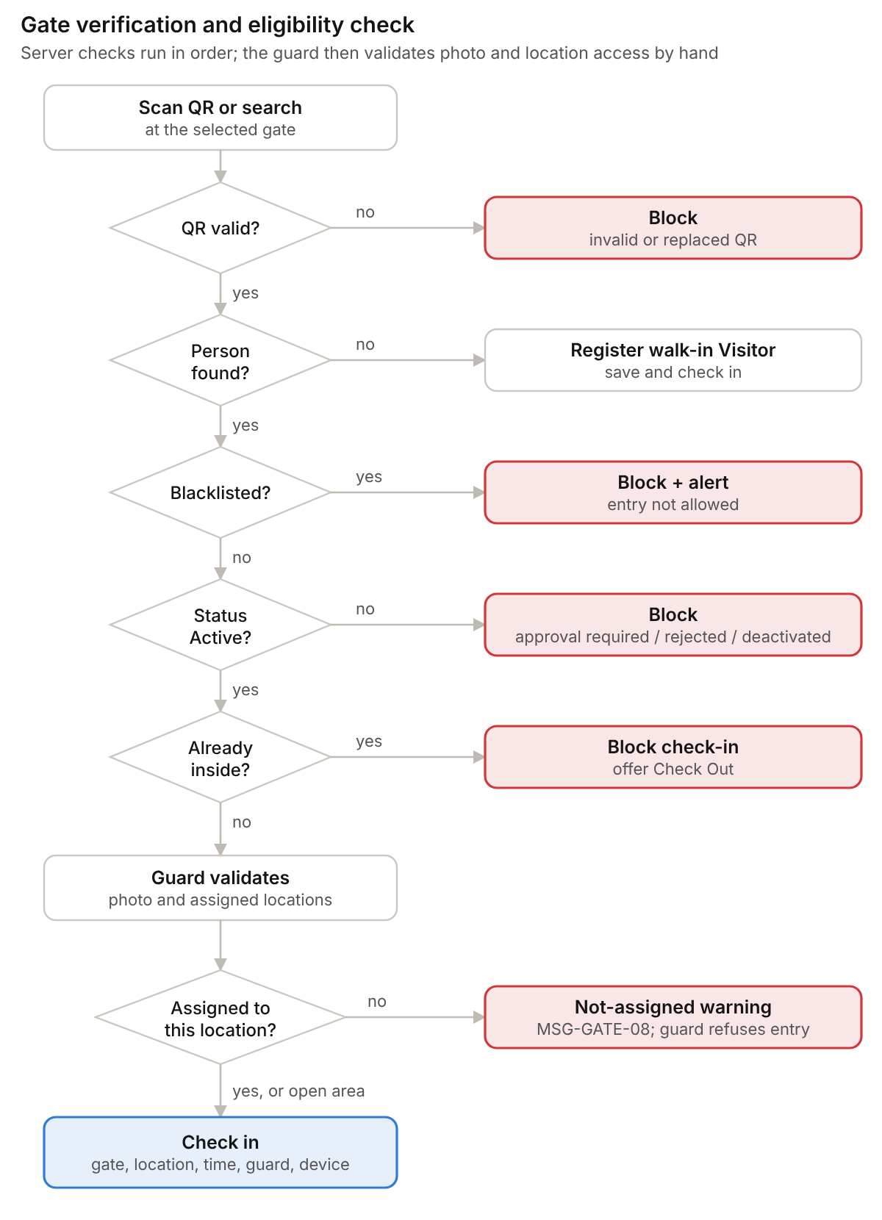
Figure 14. Gate verification and eligibility check
Every blocked attempt is stored with its result and reason and counts in "Blocked attempts today".

17.4 Person not found: walk-in Visitor
Step | Guard action | System response
1 | Search returns no match | Shows Registration required (MSG-GATE-02) and Register Visitor button
2 | Opens short Visitor form | Fields: first name, last name, mobile, gender, resident status, photo, purpose, person to meet, accompanying members
3 | Taps Save and Check In | Visitor registered as Active, QR generated and check-in recorded in one step

Condition | Rule
Entry without registration | Not allowed: visitor registration is mandatory before entry

17.5 Blacklist check
When a blacklisted person is found the screen shows BLACKLISTED PERSON — ENTRY NOT ALLOWED (MSG-GATE-03), check-in is blocked, and Admins and the Security Head are alerted.

17.6 System or network unavailable
If the system or network is down at a gate, the guard records entry and exit in the manual register and entry continues on paper. Register entries remain on paper and are not back-entered into the system.

18. Check-In Module
Allowed roles: Security Guard, Registration Officer, Approver, Admin.

18.1 Validation rules
Rule | If it fails | Message
Person must exist | Registration required | MSG-GATE-02
Person must be Active | Approval required / Registration rejected / Profile deactivated | MSG-GATE-04
Person must not be blacklisted | Entry blocked | MSG-GATE-03
Duplicate entry prevention: only one open visit per person | Person already inside | MSG-GATE-06

Example: check-in done, no check-out recorded, second check-in attempted = blocked with "Person already inside since [time] at [point]".

18.2 Check-in data captured
Field | Source
Person | Scanned or searched registration
Check-in gate | Selected on the device
Check-in location | Selected on the device
Date and time | Server clock, IST
Checked in by | Logged-in user
Device | Device name
Accompanying members | Names or count, pre-filled from the registration and editable

Double-tap protection: the same action for the same person within 5 seconds is ignored. Exactly one open visit per person is enforced by the database.

19. Check-Out Module

19.1 Validation
Condition | System behaviour | Message
Person has an open check-in | Check-out allowed at any gate | —
Person has no open check-in | Check-out blocked | MSG-GATE-07

19.2 Check-out data captured
Field | Source
Person | Scanned or searched registration
Check-out gate | Selected on the device
Check-out location | Selected on the device
Check-out time | Server clock, IST
Checked out by | Logged-in user
Device | Device name
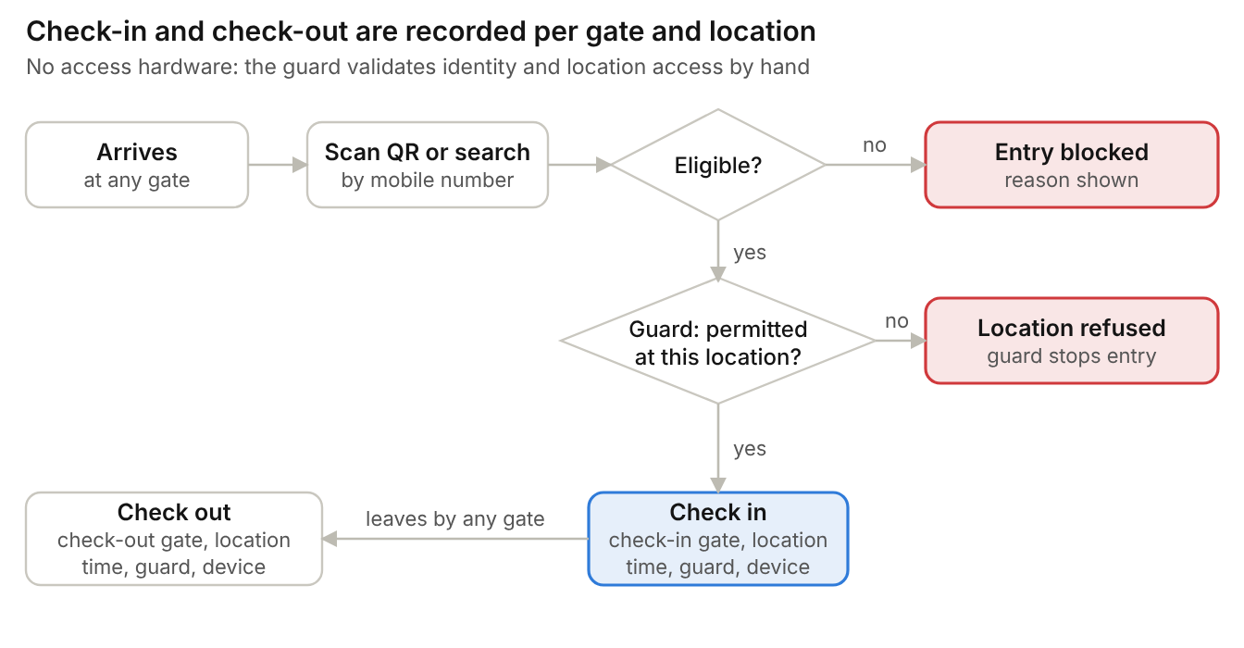
Figure 15. Check-in and check-out with gate and location

20. Occupancy Module

20.1 Logic
Current occupancy = number of open visits (check-ins without a check-out). This equals total check-ins minus completed check-outs, and makes a forgotten check-out visible instead of hiding it. Occupancy is shown for the whole Ashram and by location. Accompanying members are shown separately (for example "485 inside + 32 accompanying") and are not added to the occupancy count.

20.2 Dashboard widgets
Widget | Definition | Refresh
Current occupancy | Open visits now, by category and by location | 30 s
Today's check-ins | Check-ins since 00:00 IST | 30 s
Today's check-outs | Check-outs since 00:00 IST | 30 s
Pending approvals | Persons in Pending status; links to the approval queue | 60 s
Blacklisted attempts | Check-in attempts blocked by the blacklist today | 30 s
Inside list | Persons checked in but not checked out; overstays highlighted | 60 s
Recent activity | Last 10 gate events | 30 s

20.3 Inside list and overstay
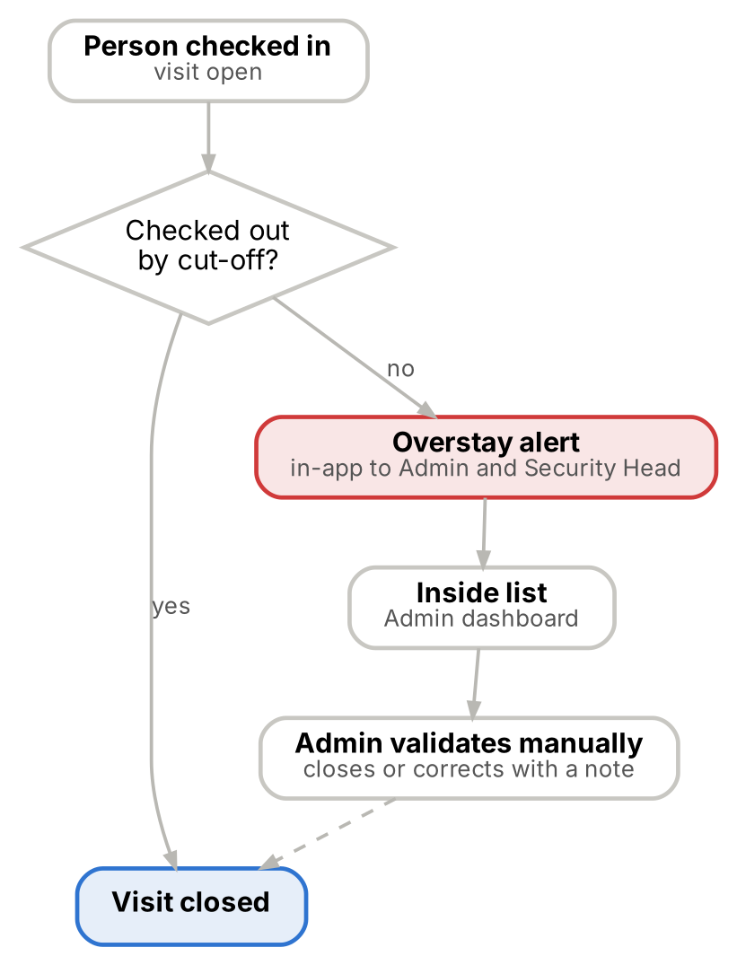
Figure 16. Inside list, overstay alert and Admin validation
ID | Requirement
FR-OCC-01 | There is no auto-checkout.
FR-OCC-02 | Overstay: a person still inside after their category's cut-off time raises an in-app overstay alert. Day visitors and contractors must leave by 10:00 PM; cut-offs for other categories are set in the Category master.
FR-OCC-03 | The Inside list on the Admin dashboard and in reports shows every open visit with person, category, check-in time, point and hours inside; overstays are highlighted.
FR-OCC-04 | Admin validates manually and closes or corrects an open visit with a mandatory note; the visit is marked "Closed by Admin" and audited.

21. Blacklist Module

21.1 Add to blacklist
Only Admin can perform this. Any registered person of any category can be blacklisted.
Field | Mandatory | Validation
Person | Yes | Selected by search
Reason | Yes | From Blacklist Reason master
Remarks | Yes | ≤ 500 characters
Start date | Yes | Default today
End date | No | Blank means indefinite; cannot be before start date (MSG-BL-01)
Added by, added on | System | Recorded automatically for audit

21.2 Rules
ID | Requirement
FR-BL-01 | Impact: takes effect immediately at every gate; check-in is blocked.
FR-BL-02 | A person already blacklisted cannot be added again (MSG-BL-02); edit the existing entry instead.
FR-BL-03 | Blacklisting a person who is inside does not check them out; it alerts Admins and the Security Head so the person can be escorted out.
FR-BL-04 | Remove (lift): Admin confirms with a note; the person becomes eligible for entry; the entry keeps its history.
FR-BL-05 | Entries past their end date stop blocking automatically and are marked Expired.
FR-BL-06 | Blacklisted persons are excluded from the public QR lookup.

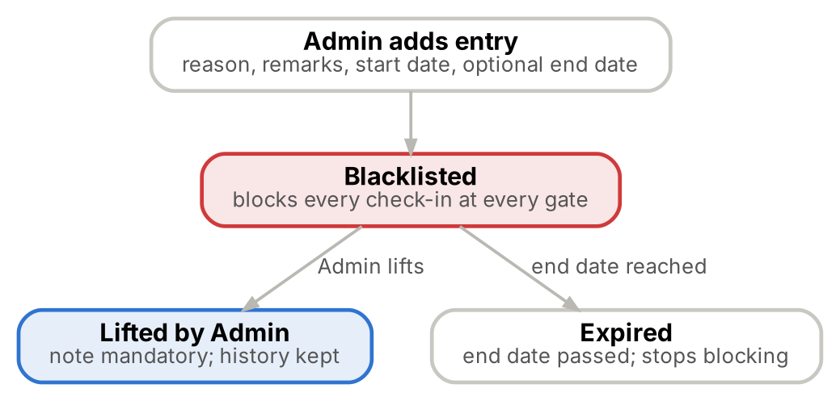
Figure 17. Blacklist lifecycle

22. Reports Module
All reports page on screen, follow role permissions and mask mobile and ID numbers for non-Admin roles. In the MVP only the Visit History report is exported; export of other reports and dashboard analytics follows in a later phase.
Report | Filters | Columns | Export in MVP
Registration (Person) report | Category, status, department, registered date range | Person ID, name, category, mobile, status, registered by, date | Later phase
Visit History report | Name or mobile, category, date range, gate, location | Person, mobile, category, date, gate, location, event (in/out), by, device, accompanying members | Excel and CSV
Occupancy report | Date, location | Date, location, check-ins, check-outs, peak inside, open at day end | Later phase
Staff report | Department, job role, status | Person ID, name, department, job role, shift, joining date | Later phase
Pending Approval report | Category, status, submitted date range | Person ID, name, category, submitted by, date, decision, decided by | Later phase
Blacklist report | Reason, date range, active or expired | Person, reason, start, end, added by, lifted by | Later phase

A Visit History export with a one-month date range is the monthly in/out movement report.

23. Notification Requirements
All notifications in the MVP are in-app. The bell icon shows the unread count; notifications are kept for 30 days. SMS, WhatsApp and Email notifications are excluded from Phase 1 because of their recurring operational cost.
Event | Recipients | Channel
Registration submitted (Staff, Parivar Member) | All Approvers and Admins | In-app
Registration approved | Submitter | In-app
Registration rejected | Submitter, with reason | In-app
Blacklisted person scanned | Guard on screen; Admins and Security Head | In-app, immediate
Blacklisted person currently inside | Admins and Security Head | In-app, immediate
Overstay beyond cut-off | Admins and Security Head | In-app

24. Audit Log Module

24.1 Activities tracked
Module | Activities audited
Security | Login, logout, failed login attempts, lockout, create password, change password, password reset
User management | User creation, update, deletion, activation and deactivation; role and permission changes
Registration | Create, edit, deactivate, reactivate; mobile number, email, passport, category and location changes; location assignment
Approval | Approve, reject, resubmit
QR | Generate, regenerate, public lookup (masked mobile and result)
Bulk upload | Upload initiated, upload completed, upload errors
Blacklist | Add, edit, lift
Gate | Check-in, check-out, gate movement, blocked attempt, location warning
Occupancy | Admin closes or corrects an open visit
Reports | Export
Administration | Master data changes, including category create, update and delete, permission levels and location access rights

24.2 Audit information stored
Field | Description
Changed by (user name and role) | Who performed the action
Activity performed | For example Approve, Check-in
Module | Registration, Approval, Gate and so on
Entity and ID | Record affected
Date and time | Server time, IST
Old value | Changed fields only
New value | Changed fields only
IP and device | Where the action came from

24.3 Rules
ID | Requirement
FR-AUD-01 | Only Admin can view the audit log; filter by date, user, module, action and entity; the detail view shows previous and new values side by side.
FR-AUD-02 | Audit entries cannot be edited or deleted through any screen or API.
FR-AUD-03 | Passwords, tokens and full ID numbers are never written to the audit log.
FR-AUD-04 | Audit entries are retained for the period set in the data retention policy, in line with DPDP requirements (pending).
FR-AUD-05 | Every data modification in the system is logged with activity performed, old value, new value, changed by, and date and time.
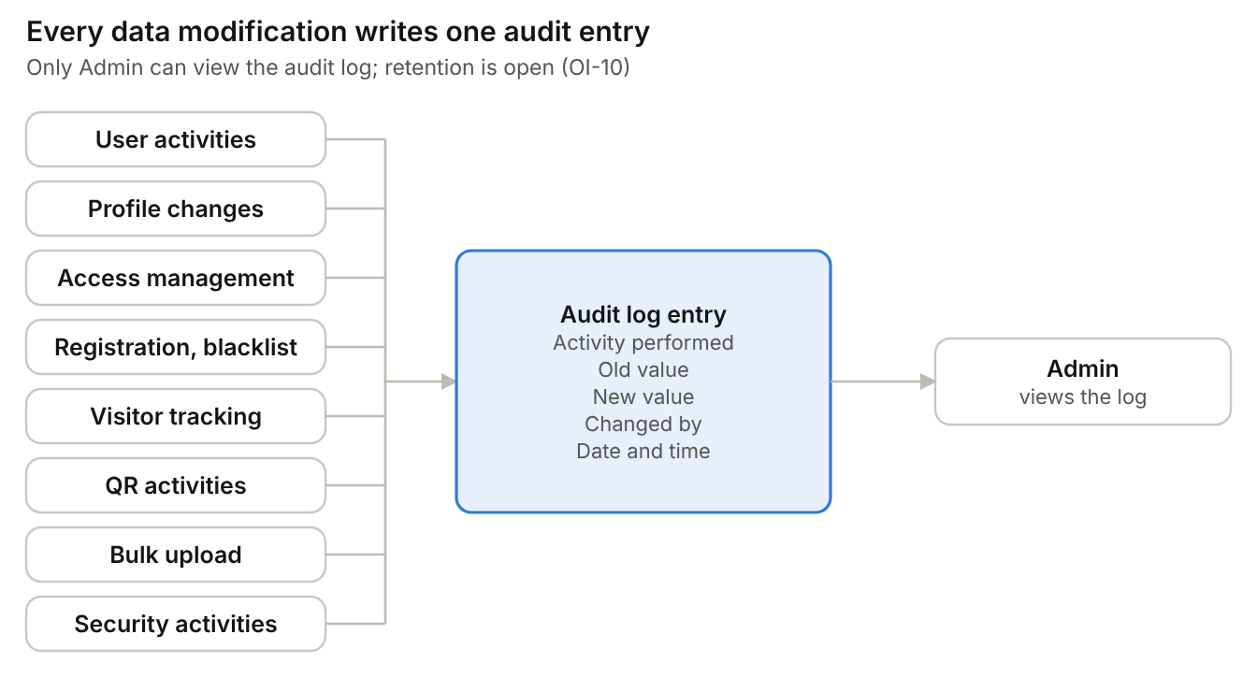
Figure 18. Audit events and audit entry attributes

25. Error Messages
Code | Scenario | Message
MSG-SEC-01 | Invalid login | Invalid username or password.
MSG-SEC-02 | Account locked | Too many attempts. Try again in 15 minutes or contact your administrator.
MSG-SEC-03 | Password created | Password created. Please log in.
MSG-SEC-04 | Session expiring | You will be signed out in 1 minute. Stay signed in?
MSG-SEC-05 | User not found | User not found. Contact your administrator.
MSG-SEC-06 | Old password wrong | Old password is incorrect.
MSG-SEC-07 | Passwords differ | New password and confirm password do not match.
MSG-SEC-08 | Same password | New password must be different from the old password.
MSG-SEC-09 | Password changed | Password changed. Please log in with your new password.
MSG-REG-01 | Mobile already has registrations | This mobile number already has [n] registration(s): [list]. You can continue.
MSG-REG-02 | Photo invalid | Choose a JPG or PNG image no larger than 5 MB.
MSG-REG-03 | Name invalid | Use letters, spaces and hyphens only (max 100).
MSG-REG-04 | Saved | [Name] registered as [Person ID]. QR generated. / QR will be generated after approval.
MSG-REG-05 | Empty search | Enter a Person ID, mobile number or name.
MSG-REG-06 | No results | No records found.
MSG-REG-07 | Category not permitted | Your role cannot register this category.
MSG-REG-08 | Passport missing | Passport number is required for Non-Resident / International persons.
MSG-APR-01 | Short rejection reason | Rejection reason must be at least 10 characters.
MSG-APR-02 | Self-approval | You cannot approve a registration you submitted.
MSG-QR-01 | Public lookup miss | No active registration found for this number.
MSG-GATE-01 | Invalid QR | Invalid or replaced QR code. Search by mobile number.
MSG-GATE-02 | Person not found | Registration required.
MSG-GATE-03 | Blacklisted person | BLACKLISTED PERSON — ENTRY NOT ALLOWED. Security has been alerted.
MSG-GATE-04 | Not active | Approval required. / Registration rejected. / Profile deactivated.
MSG-GATE-06 | Duplicate check-in | Person already inside since [time] at [point]. Check out first.
MSG-GATE-07 | No check-in found | No active check-in found.
MSG-GATE-08 | Location not assigned | Not assigned to [location]. Check access before allowing entry.
MSG-BL-01 | Bad dates | End date cannot be before start date.
MSG-BL-02 | Duplicate blacklist | This person is already blacklisted.

26. Complete Business Flow
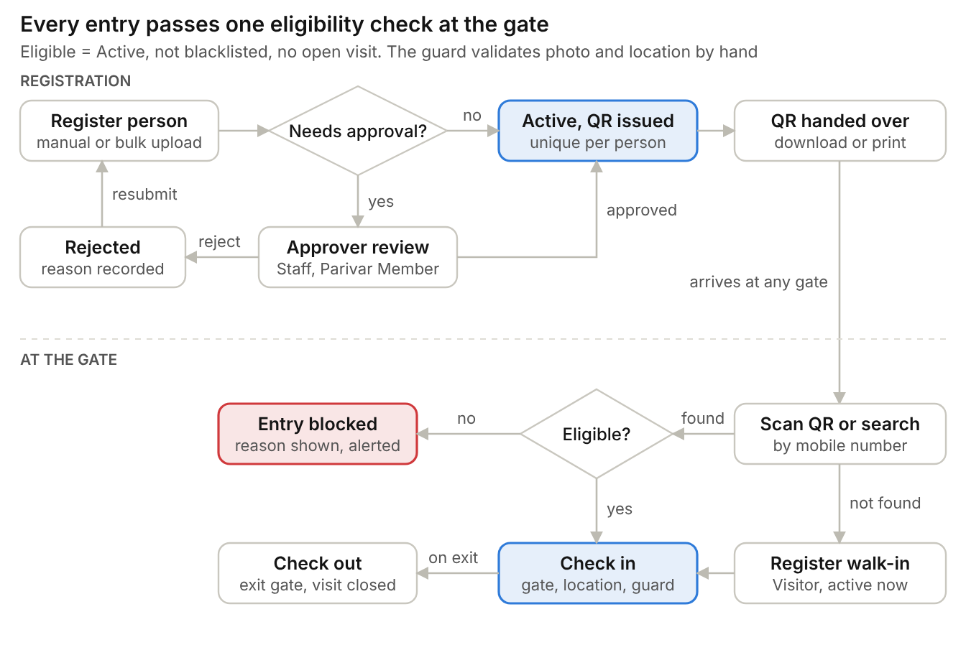
Figure 19. Complete business flow, registration to exit
Step | Actor | Action | Result
1 | IT team / Super Admin / Admin | IT adds Super Admin in database; Super Admin adds Admins; Admin adds other users and master data; each user creates a password at first login | System ready for use
2 | Registration Officer | Register person with photo, resident status and assigned locations, or bulk upload a file | Registration saved
3 | System | Check category approval rule | Staff / Parivar Member → Pending; others → Active
4 | Approver | Approve or reject Pending registration | Active, or Rejected (edit and resubmit)
5 | System | Generate QR for Active registration | QR available
6 | Person | Download QR from public lookup page by mobile number, or collect printed QR at front desk | Person holds QR
7 | Security Guard | Scan QR or search by mobile number at any gate | Profile shown
8 | System | Eligibility check: QR valid, not blacklisted, Active, not already inside; location assignment shown | Allowed or blocked with reason
9 | Security Guard | Validate person against photo and assigned locations and check in; or register walk-in Visitor if not found | Visit open; occupancy updated
10 | System | Monitor open visits against category cut-off | Overstay alert if still inside
11 | Security Guard | Check out at any gate; gate and location recorded | Visit completed

27. Assumptions
The system is built on the following assumptions.
Area | Assumption
Gate verification platform | Approved: Responsive web application on phone or tablet; native app in a later phase
Approval rule | Approved: Approval required flag in Category master; seeded Yes for Staff and Parivar Member
Photo capture method | Approved: Camera capture allowed
Accompanying members in occupancy | Approved: Need to add to the occupancy count
Overstay cut-off and alert recipients | Approved: 10:00 PM for day visitors and contractors; other categories set in Category master; Admins and Security Head receive alerts
Manual register entries after downtime | Approved: Stay on paper, not entered into the system (Later on Admin will upload via bulk upload)
Blacklist end date | Approved: Optional end date; blank means indefinite
Non-Resident / International mobile numbers | Approved: 10-digit Indian mobile required; Passport Number mandatory for Non-Resident / International
Visit History export format | Approved: Excel and CSV
Data retention and DPDP | Approved: DPDP compliance applies; detailed requirements from the business side are pending. Retention periods are set by Ashram Management
Scale and sizing | Approved: Indicative: 1000+ person records, 500 concurrent users
Access-control hardware | Approved: None planned; location and gate access is monitored manually by Security
OTP, SMS, WhatsApp, Email | Approved: Excluded from Phase 1 due to recurring operational cost
Bulk upload template | Approved
Category mapping | Approved: Mapping of the seed categories to Volunteer, Active Member and Visitor to be confirmed

